User Manual

GUI_mapas.m

Version 0.11

Contributions:

18/3/2016: Antonio R. Jiménez (CAR-CSIC)

Contenido

1. Introduction 3

2. Quick user guide 3

3. Calibration of indoor bitmaps 5

1.1 Selecting the indoor map images 5

1.2 Creating the calibration file 6

1.3 Adjusting the indoor bitmap over the Google Maps background 6

1.4 Calibrating the scale of the indoor map 7

1.5 Using external marks to calibrate the rotation and position of the floor bitmaps 8

1.6 Process for multiple floormaps and saving results 8

4. Creating a ground-truth trajectory 9

5. Processing a logFile captured in a smartphone with GetSensorData App 10

6. New features 13

# Introduction

The available floor maps for a given building are typically based on engineering CAD formats. This maps are not usually geo-referenced, so it is not easy to use then in navigation applications where a mobile device has information about his location using a globally referenced coordinate frame such as WGS84 (the one used by GPS). For the 2016 IPIN competition and for the planned collaborative positioning/navigation activities in the Spanish REPNIN network we considered useful to create a tool in order to easily and systematically calibrate maps, create ground-truth points and to test the performance of different positioning algorithms.

This document describes how to use an interactive tool called "GUI_mapas" that has been created using Matlab software. This tool is used to geo-reference indoor-maps (bitmaps of different floors in a building) and sequences of points (ground-truth marks). Additionally it can be used to manipulate the sensorial LogFiles created with the "GetSensorData" Android App in order to include/delete the ground-truth points inside those Logfiles. Other potential uses are to insert the positioning results obtained from different algorithms (competitor’s results) in order to evaluate its performance using a systematic metric (e.g, 3rd quartile of error).

# Quick user guide

The tool has a simple interface as can be seen in Figure 1.

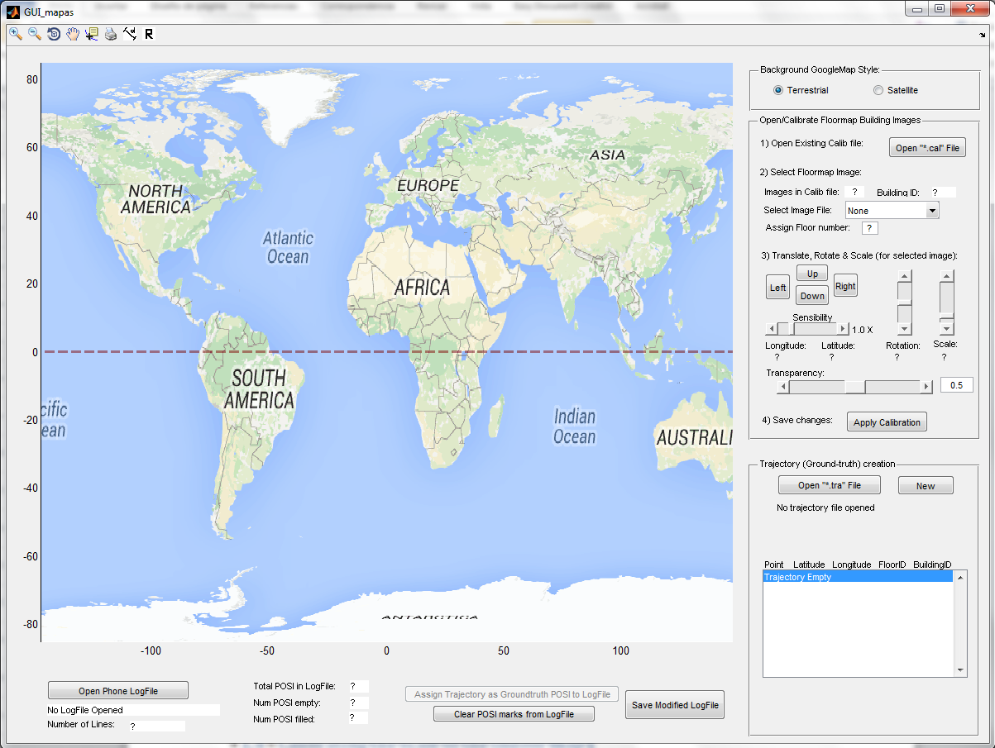

Figure 1. Interface of "GUI_mapas.m"

It has 6 different areas as can be seen:

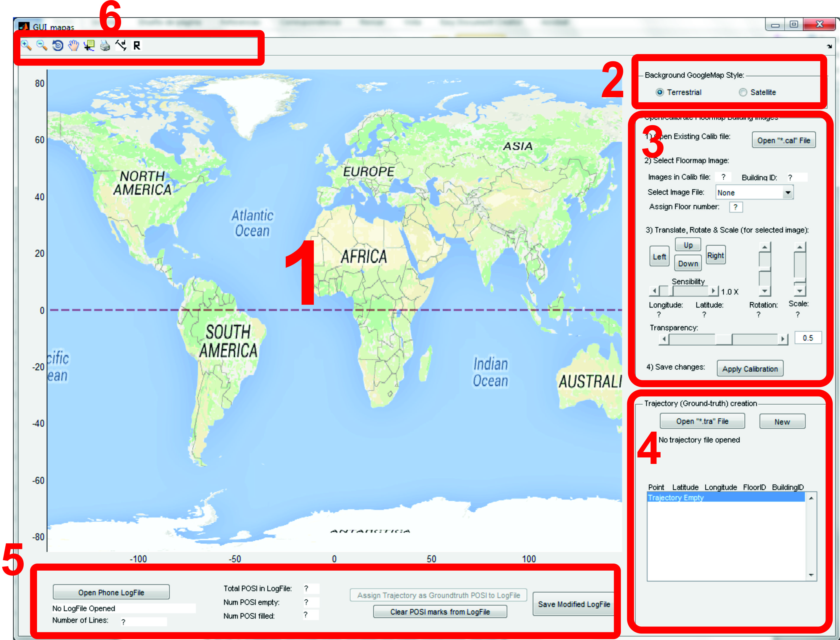

Figure 2. Areas in GUI with controls 6 for different purposes.

In area 1 (marked with a red “1” number) we can see a Google Maps image that it is georeferenced (abscissa axis represent longitude in degrees and vertical axis is latitude). The view can be terrestrial or satellite; this view type can be selected from area number 2.

Area 3 is devoted to calibration of local bitmaps representing one or several indoor floormaps.

Area 4 is used to create the ground-truth path (set of points) with indication of the Latitude, Longitude, FloorID and BuildingID.

Area 5 is used to manipulate the LogFile generated in a smartphone while capturing the sensorial data with the "GetSensorData" Android app.

Area 6 contains controls for zooming in and out, dragging, and measuring distances.

Next GUI versions will include additional control areas for algorithmic localization assessment (competitor’s evaluation), and any other functionality that can be considered of interest.

# Calibration of indoor bitmaps

In this section we will describe the calibration (geo-referenciation) of bitmaps using the buttons visible in area 3 of Figure 2, which are magnified next:

. 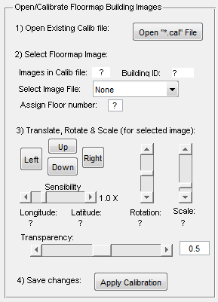

Figure 3. Controls for indoor map calibration

## Selecting the indoor map images

First we need to have one or several image bitmap files with the indoor details. In current version only jpg images are supported. For example, you should generate this kind of floor maps from a CAD file:

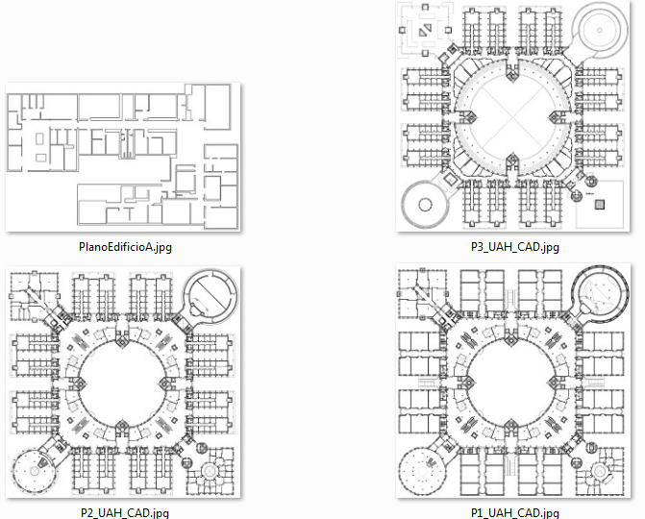

Figure 4. Sample bitmap indoor floor maps

## Creating the calibration file

The tool does not include yet the initial creation of the calibration file, so it is required to manually create an approximate calibration file (this process is required to be done only once). This is an example of a calibration file with 4 floors (3, 2, 1 and 0) and one building (ID 1):

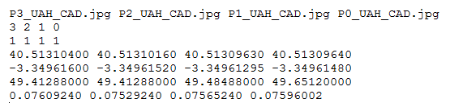

The calibration file is a text file with extension ".cal". Each floor in the calibration file has to have 7 calibration data rows:

1. the filename of the bitmap
2. the floor number or ID (e.g. -2, 0, 3)
3. the Building number or ID (e.g. 10, 20, 30)
4. Latitude (in degrees) of image center,
5. Longitude (in degrees) of image center,
6. Rotation CW (in degrees) of image to be aligned to the geometric north
7. Scale (meters/pixel).

A calibration file has always 7 lines, and a variable number of columns, as many columns as the number of floors in the building (in this example there are 4 columns for 4 floors).

Once created the approximate calibration file, we can open it and refine the file using the controls in Figure 3, as we preset next.

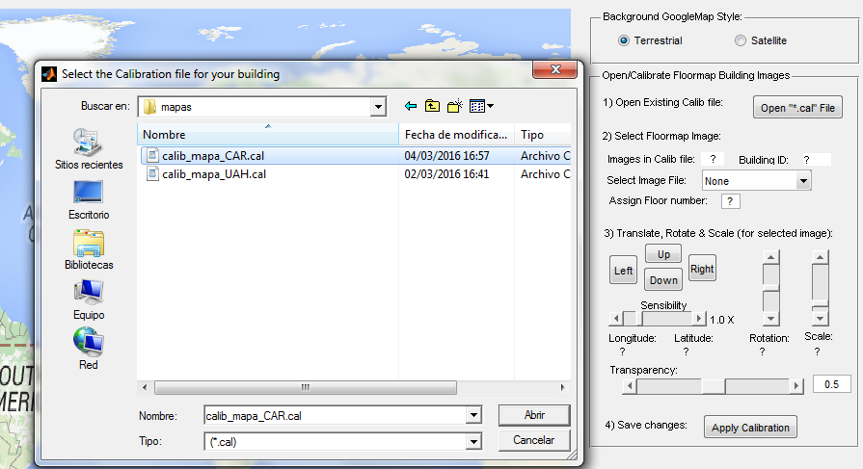

Figure 5. Opening a calibration file

## Adjusting the indoor bitmap over the Google Maps background

Once the calibration file is opened, the Google map is zoomed in to the position where the indoor maps are georeferenced. If the building has multiple floors, we can select the desired floor map to calibrate.

We have to use the available controls to translate, rotate and scale the maps, in order to fit as best as possible the bitmap over the Google maps satellite or terrestrial view. A sensitivity control is used to adjust the step of the other translation/rotation/scale controls. In order to ease the overlapping of both images (indoor with respect the Google maps) we can change the transparency of the bitmap.

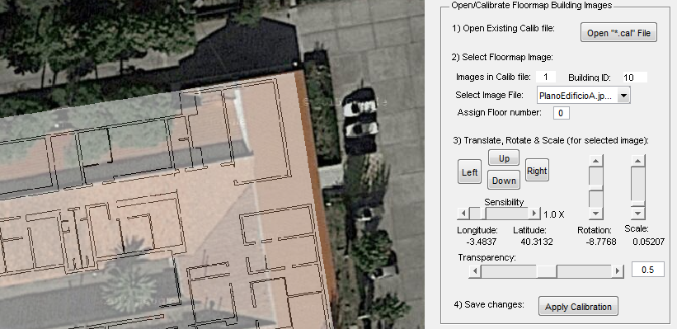

Figure 6. Indoor map superposed to Google maps

## Calibrating the scale of the indoor map

In order to reduce the uncertainty in the calibration it is recommended to check the calibration of the scale of the map using a distance meter device (laser meter or a long metric tape). We can physically measure the length of some corridors or halls in the real space and then compare that real distance with the distance estimated with a distance tool (top tools in GUI).

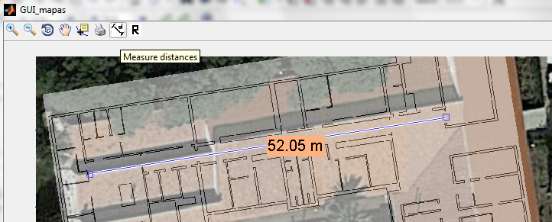

Figure 7. "Measurement distance" tool can be used to verify the correct calibration of the scale (meters/pixel)

Adjust the scale, until the experimental distance fits the distance measured with the GUI tool.

## Using external marks to calibrate the rotation and position of the floor bitmaps

As Google satellite view has significant errors due to non-zenithal capture of images, it is usual to have an error of several meters from the roof of the building with respect to the ground. In these cases using the roof as a reference for calibration can cause important errors (larger than 2 meters). In order to refine the translation and rotation of the floor bitmap again it is recommended to measure the real distance (laser meter) between some marks in the outdoor terrain with respect to some outer walls in the building. In this way we can refine the calibration with respect the ground in Google maps which is more reliable. Here we have an example of how to do this process:

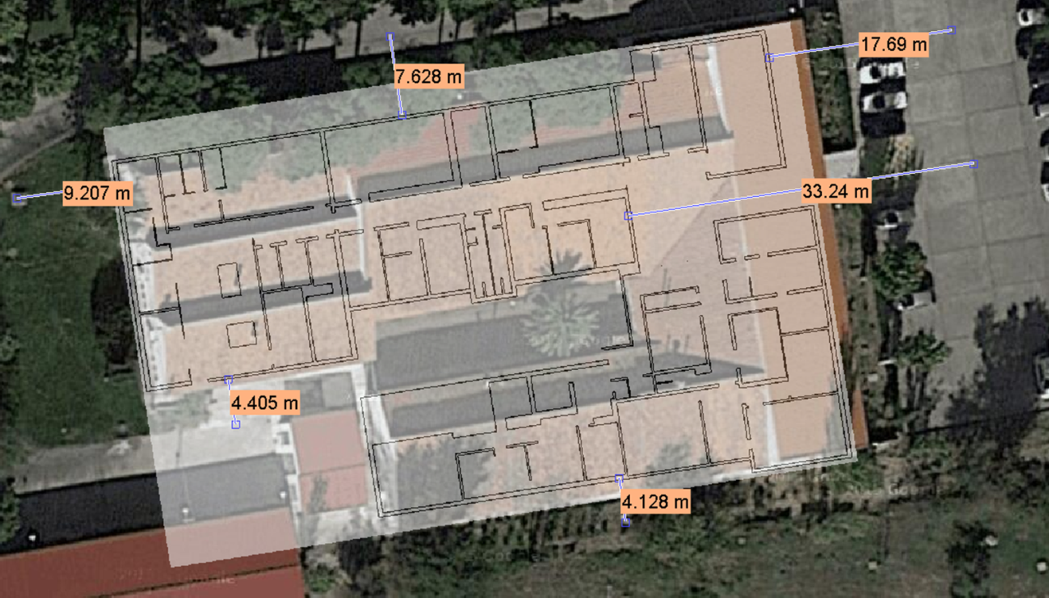

Figure 8. Fine image calibration using some physical range measurements. A total of 6 easily visible points are used to check the correct positioning of the bitmap over the Google maps view.

The maximum discrepancy of the 6 physical distances with respect to the annotated distances on the GUI is 0.4 meters. So we can guarantee a final calibration accuracy that is lower than 0.5 meters.

## Process for multiple floormaps and saving results

Once one floormap image is calibrated (georeferenced) we can select another floormap (another jpg with in the calibration file) in the GUI and start repeating the same process.

After all calibrations are done do not forget to save changes ("Apply calibration" button). A file like the next one will be created that replaced the original one that was manually created.

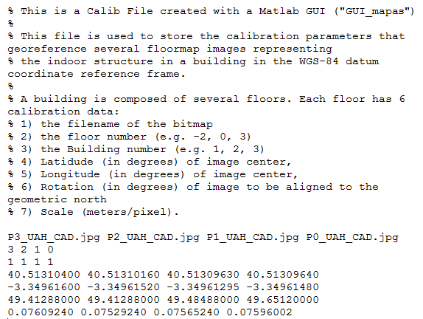

Figure 9. Generated calibration file after saving changes over the original manual calibration

You can open this calibration file as many times as you need if a recalibration is needed, and also you will have to open it in order to have it as a reference for the next process: “Creating a ground truth trajectory” that is explained next.

# Creating a ground-truth trajectory

You can create a sequence of geo-referenced ground-truth points using the control buttons in area 4 shown in Figure 2. You can press the “New” button in order create a new trajectory and later on “Draw points to the trajectory” button to change the cursor mode to collect the ground-truth points by clicking with the left mouse button on the indoor map image. Then, when you decide to **finish**, click the right mouse button, in that way you will finish adding points, collect all point coordinates and the yellow labels with the numbers will be shown. See Figure 10 for an example.

a)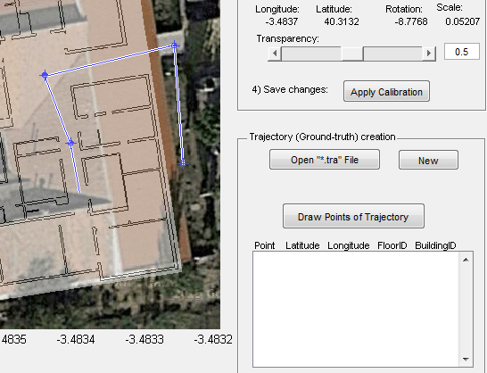 b) 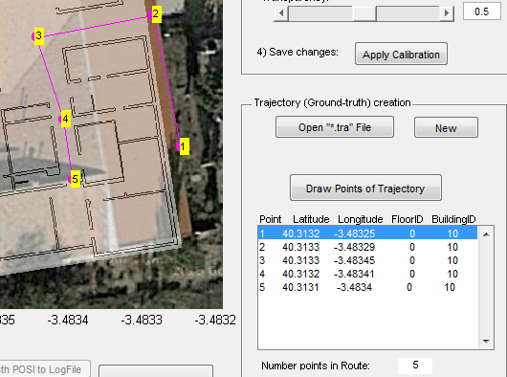

Figure 10. Creating a sequence of geo-referenced ground-truth points. a) after pressing “Draw points to the trajectory” button you can click on the image to generate a list of points. b) when you finish, click the right mouse button in order to recollect all coordinates and to show the labels with the numbers.

At any time, you can **add more points** to the last section of the trajectory by pressing again to the “Draw points to the trajectory” button. You can also **move** the already drawn points by moving the cursor on the point, until a circle appears, and then dragging the point to your new desired destination. You can also **insert new points** between two existing points in the trajectory by pressing the “A” key on the keyboard while moving the mouse pointer on the link that join to consecutive points, and pressing the left-side mouse button.

For multiple store buildings, you should change the floor number in the control of area number 3, and continuing clicking for new ground-truth points in over the new floor image. Currently a visual overlap exists among points from different floors (it can be confusing); in a new software update this should be made individually configurable by selecting the desired layers to show in other to help visualization.

After finishing all the collection of ground-truth points you can save it into a trajectory file. A trajectory file is a text file ending in “.tra”. See next figure with a sample:

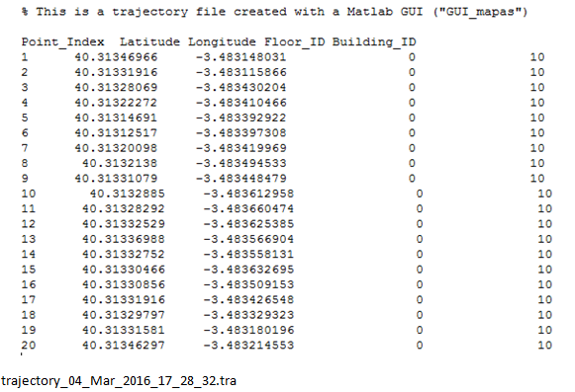

Figure 11. Trajectory file sample created with the mouse controls (this ground truth points can be used for calibration of sensor data and for checking the accuracy of positioning algorithms in IPIN competition).

# Processing a logFile captured in a smartphone with GetSensorData App

Using the GetSensorData (see Figure 12) you can generate logFiles with all the sensorial information that can be captured within a smartphone while a person is doing an indoor test.

a)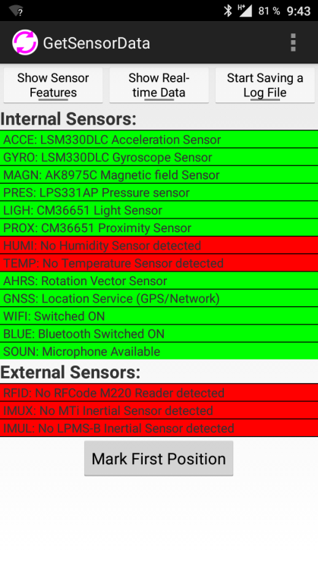b)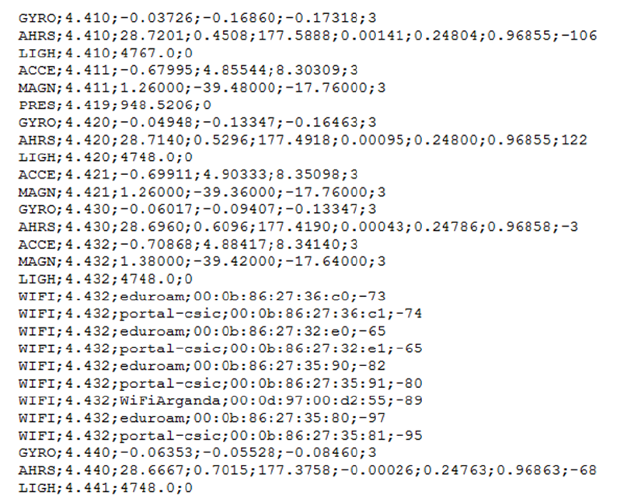

Figure 12. GetSensorData Android App. a) Interface with a “Mark” button to generate the POSI lines. b) an example of a LogFile with the different Sensor data within a phone.

In the recording process, by pressing a button on the GetSensorData App you can identify the instant when you are on a known control point (ground-truth mark). These marks in the logFile correspond to text lines beginning with a “POSI” header, and with a time and mark ID, and additional fields separated by “;” for the localization ground-truth. This is a POSI line example:

POSI;30.341;1;0.00000000;0.00000000;0;0

In this example, the POSI line tells us that it corresponds to mark number 1 taken at time 30.34 seconds from the start of the experiment. Note that no Latitude or longitude, building or floor ID is included.

In the control section of the Matlab GUI (section number 5 of Figure 2), we can find the tools to integrate the ground-truth (GT) points created before (a “*.tra” file) with the sensor logFile corresponding to an experiment. Once the trajectory file with the GT points is opened, we can open the logFile by pressing the “Open Phone LogFile”, as shown in Figure 13.

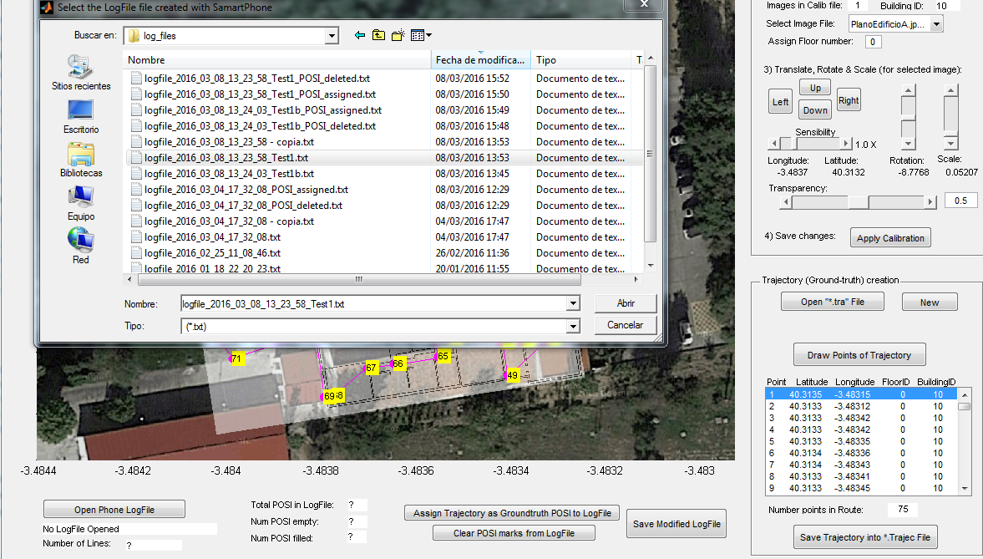

Figure 13. Opening a logFile in order to assign the true Latitude, Longitude, BuildingID and FloorID to POSI lines.

When opening the logFile, it starts the parsing of the file, which due to its big size can take several seconds. Once the parsing is finished, the controls area (see Figure 14) will show the number of lines in the log files, and the number of POSI marks found (distinguishing between empty ones and filled ones (i.e. those with a correct GT).

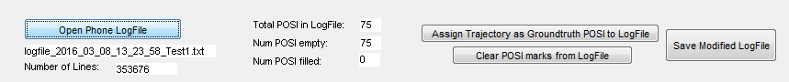

Figure 14. After opening a logFile the number of lines, and POSI marks are shown

Now, we just have to press the “Assign Trajectory as Ground-Truth POSI to LogFile” button to do the integration of both sources of information. When we press “Save modified LogFile” button we create a new the LogFile ending with “_POSI_assigned.txt” that has the POSI lines with the correct GT; for example:

POSI;30.341;1;40.31347091;-3.48315;0;10

The generated logFiles ending with “_POSI_assigned.txt” are those that must be included in databases for calibration of positioning algorithms. These type of files are those to be made available to competitors in the IPIN competition.

We can also generate logFile without any POSI mark (by pressing the “Clear POSI marks from logFiles”). These files are the ones used for evaluation of the performance of competitors (no GT included). The same logFile but ended in “_POSI_deleted.txt” will be reserved for the organizers to rank participants.

# New features

There are still pending some new features in this GUI_mapas Matlab software, for example:

* A panel for loading the competitor’s localization results, and then for generating the location errors, CDF and 3rd percentile error used for ranking competitors.
* Debugging of many functionalities already implemented
* Any new idea

Please, fill free to edit this user manual, and the Matlab algorithms. Both the code and the manual document will be available at this **SVN repository**:

<https://161.111.121.5/svn/GUI_mapas>

and can be accessed for example with the TortoiseSVN client.